**Managing Onboarding Checklists & Viewing Employee Files**

* To begin Onboarding, you will first need to log in to PeopleAdmin from the link on the Inside.Loyola Application section.

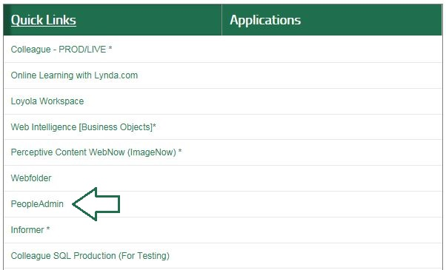

* From within PeopleAdmin on the top right corner you will see a drop down menu. From the drop down menu you will select OnBoard.

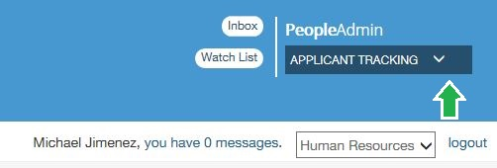

* Once you have logged in you will be taken to the My Tasks page. The My Tasks page is where you can view and complete an outstanding tasks that have been assigned to you. On this page you will have two tabs.
* The first tab will be the “Needs Attention” tab, this tab indicates all items that have been assigned to you that needs an action to be performed on it. This tab also indicates whom the task is for. To take action on an item click on the View button to the right of the item.

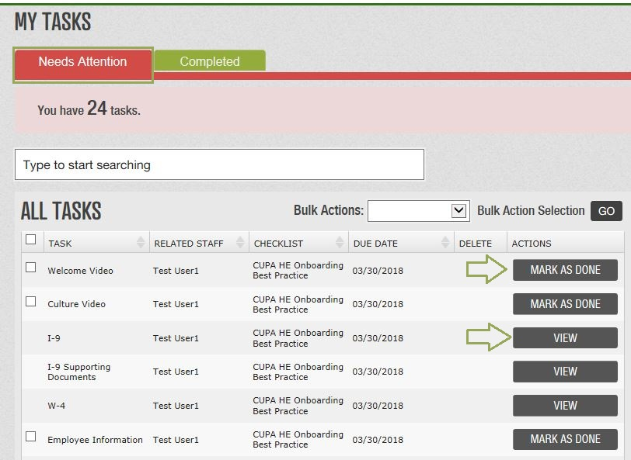

* Some Task will require you to digitally sign prior to completing the form. To sign a form you must first save the form as a final.

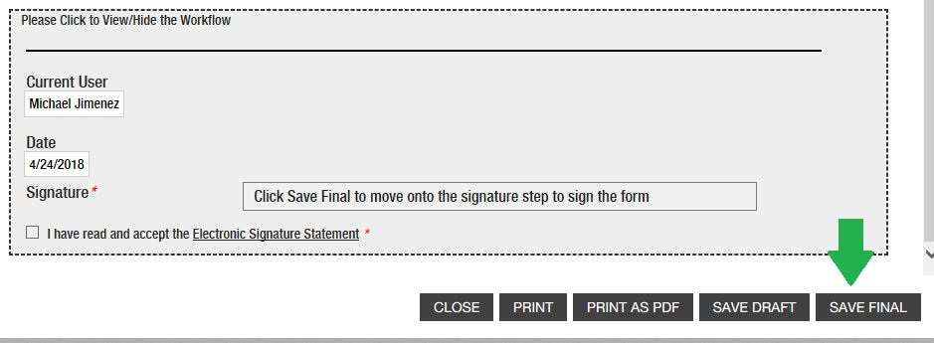

* Once the form has been saved, it will allow you to sign and submit the final document.

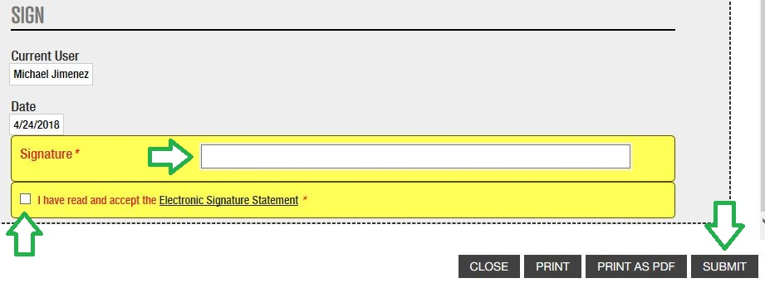

* The second tab will be the “Completed” tab, this tab indicates all items that have been assigned to you and are completed. Keep in mind that tasks may not show up on your “Completed” tab immediately, if they require an additional step by a supervisor or staff member. To review items that have been completed you can click on the View button to the right of the item.

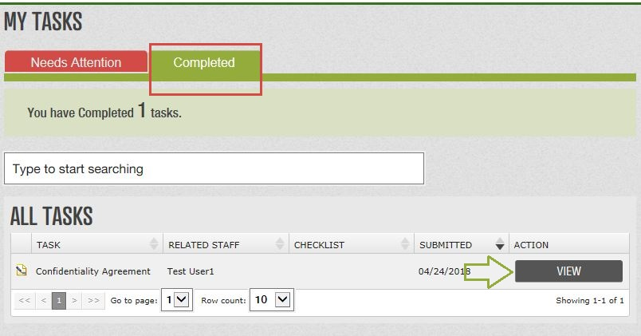

* As a Supervisor you may also submit Blank Forms on behalf of staff who report to you. They can be accessed through the “Blank Docs” icon located at the top right of the screen.

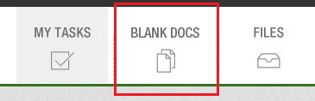

* When you open a Blank Form will be asked who you would like to submit the form for. Documents you submit for yourself will be placed in your own personal files while documents submitted for another staff member will be saved to their own files.



* Documents that have been completed by your employees will be listed on the employ Files page. You can access your employee Files page by clicking on the employees name on the left side of the screen.

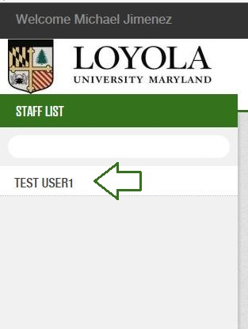

* Documents have been completed and finished routing will be sorted in the appropriate folder and sleeve. As an example, if a direct deposit form has been filled out, it will be filed in the Payroll folder and direct deposit sleeve. You may see fewer files than you will see for yourself based on the security settings defined by Human Resources. Also the sleeve can let you know if the form is still in process, example the W-4 sleeve below.

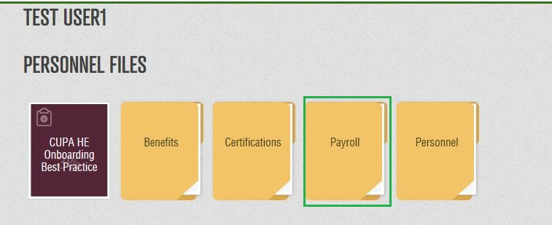

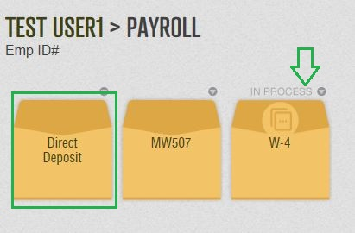

* You can receive multiple checklists at any given time. All checklists that have been assigned will appear on the “Needs Attention” tab, below you will find a list of common forms and their descriptions.

|  |  |
| --- | --- |
| **Title** | **Description** |
| W-4 Form | If no response is received for federal withholdings, defaults will be set as the system indicates. |
| Maryland State Tax Form | If no response is received for State withholdings, defaults will be set as the system indicates. |
| Policy Manual | This Staff and Administrators Policy Manual provides information about the terms and conditions of your employment, your responsibilities as a member of the Loyola community, important policies and procedures, and general information about the services, benefits, programs, and facilities related to your employment. |
| Personal Data Form | This form will collect personal data that was not included in the applicant tracking system. This form will also verify information that was provided. |
| Confidentiality Agreement | This is an agreement that the employee is responsible to keep all information outlined in the agreement confidential. |
| Title IX Resource Guide | A guideline for employees to provide an environment free from sex-based discrimination and harassment that complies with the Title IX of Education Amendments of 1972. |
| Parking Brochure | A brochure outlining Loyola’s parking policy, registration and cost. |
| Direct Deposit Agreement Form | This form allows new employees to set up direct deposit. |
| Summary of Employee Benefits Booklet | This booklet provides eligible employees look at all of the medical benefits Loyola University Maryland provides. |
| HIPPA Notice of Privacy | A Notice of how medical information about you may be used under the Health Insurance Portability and Accountability Act. |
| HealthCare Exchange Notice | This Notice provides information on the Health insurance MarketPlace and how to obtain additional information. |